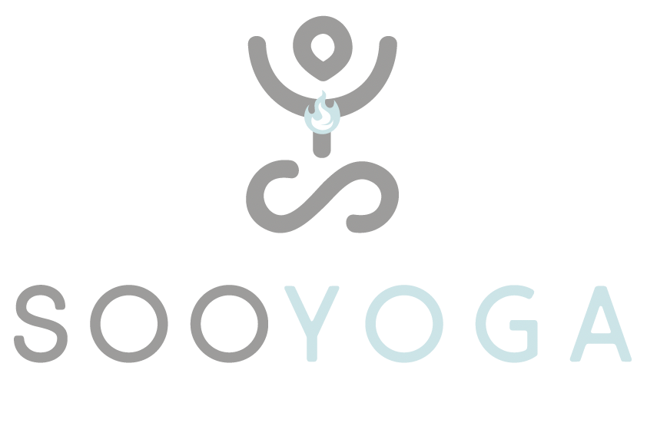
CANCELLATION FORM
To Soo Yoga Limited, Tel: 01604 621004
Sol Central, Mare Fair, Northampton, NN1 1SR
Email: info@sooyoga.com
Reason for cancelation:

*Your 12 month membership can be terminated early only on medical grounds and if you are moving out of the area.
Please attach valid documents with this form if you are moving away from Northamtonshire or medical documents to support your illness evidence.

Name of consumer(s):
Address/email address of consumer(s):
I….. hereby give notice that I would like to cancel my application for membership of Soo Yoga Centre/bookings for classes on the following dates [*] [**].
Signature of consumer
Date:
© Crown copyright 2013.

